PROMISE & PRACTICE · DEEP DIVE · SOURCE ANALYSIS
The Enforcement Acts — A House Divided
When Washington Chose to Act
Name: ______________________________ Period: _____ Date: ________________
WHAT I CAN DO TODAY I can read primary sources about The Enforcement Acts — A House Divided, weigh who made each one and why, and use evidence to answer historical questions.
Directions. One decision produced real results. Trace the causes, the effects — and what the story depends on

THE SOURCES
THE IMAGE — President Ulysses S. Grant
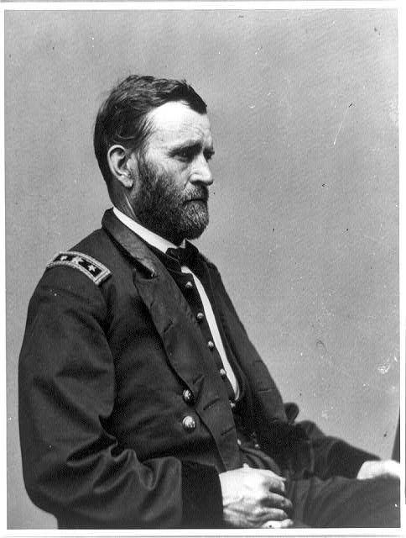
President Ulysses S. Grant — photograph, public domain (Library of Congress).
SOURCE · WHAT THE ENFORCEMENT ACTS DID — Federal power against terror
The Enforcement Acts (1870–71), including the Ku Klux Klan Act, made it a federal crime to conspire to deny citizens their rights; let the president use troops and suspend habeas corpus; and led to hundreds of prosecutions. By 1872 the Klan was largely broken and Black voting rebounded.
— summarized from the historical record. Public domain
— summarized from the historical record. Public domain.

YOUR WORK
QUESTION 1 STEP 1 · THE CAUSE
The amendments already guaranteed Black rights. Why were the Enforcement Acts still necessary?
____________________________________________________________________________________________
____________________________________________________________________________________________
____________________________________________________________________________________________
QUESTION 2 STEP 2 · THE EFFECT
What was the main effect of Grant's aggressive use of the Enforcement Acts by 1872?
☐ A. the Klan grew stronger
☐ B. the Klan was largely broken and Black voting rebounded
☐ C. nothing changed
☐ D. the amendments were repealed
QUESTION 3 STEP 3 · THE BIG IDEA
The success of the Enforcement Acts proved something important about protecting rights. In your own words, what did it prove — and why is that both hopeful and troubling?
____________________________________________________________________________________________
____________________________________________________________________________________________
____________________________________________________________________________________________
QUESTION 4 STEP 4 · THE WARNING
If rights were protected only because the federal government chose to act, what would happen when it stopped choosing to act? In three or four sentences, predict the consequence — and connect it to what you know comes next in Reconstruction.
____________________________________________________________________________________________
____________________________________________________________________________________________
____________________________________________________________________________________________
____________________________________________________________________________________________
____________________________________________________________________________________________
Promise & Practice · ShadowDog Digital Studios · Unit 2

TEACHER ANSWER KEY — The Enforcement Acts — A House Divided

QUESTION 1: Open response.
Look for a response along the lines of: “The rights existed on paper, but…, so the Acts were needed to…”
QUESTION 2: Correct — B. the Klan was largely broken and Black voting rebounded
Right. Federal prosecutions and troops largely broke the Klan, and Black Southerners were able to vote again in large numbers — proof that federal power could protect rights.
QUESTION 3: Open response.
Look for a response along the lines of: “It proved that…; this is hopeful because…, but troubling because…”
QUESTION 4: Open response.
Look for a response along the lines of: “If the government stopped enforcing rights, then…”

